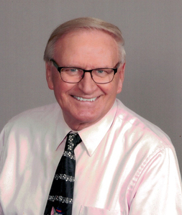

Mr. Skura, who passed away recently, was well known throughout Michigan for his music programs in Southgate. He worked tirelessly from the late 60's through the early 90's, producing one of the highest rated programs in the state. His Schafer and Anderson music programs achieved countless awards over the years, and brought endless praise to both schools and the City of Southgate.

