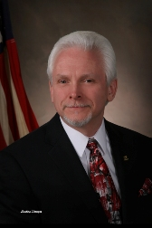

Joseph’s commitment to our schools and our community spans over a half century. He has made an impact as an accomplished student, citizen volunteer, school board member, involved parent and, most recently,
Mayor of the City of Southgate.

